homework：fact（44511105）=3×5×…

Thesis → Theory

Theorem

What percentage of problems cannot be solved by a Turing Machine?
10%, 50%, 90%or 100%?
Answer: 100% ✓

computable numbers
N ⊂Q⊂ R

Universal Turing Machine
U(⟨M⟩, x) = M(x)
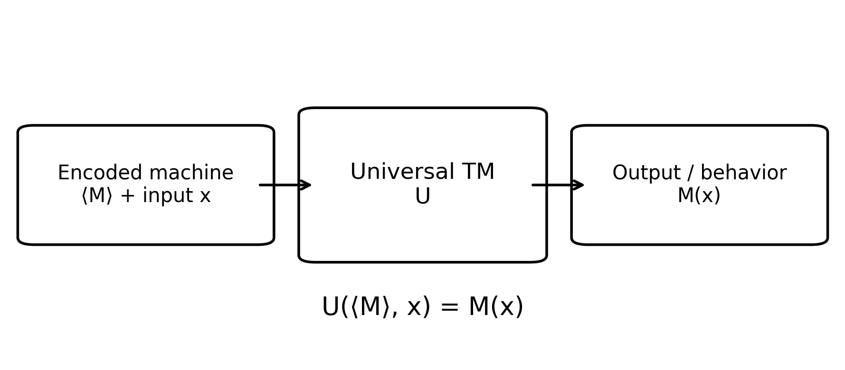
one kind of typical paradox:
Self-reference + diagonalization

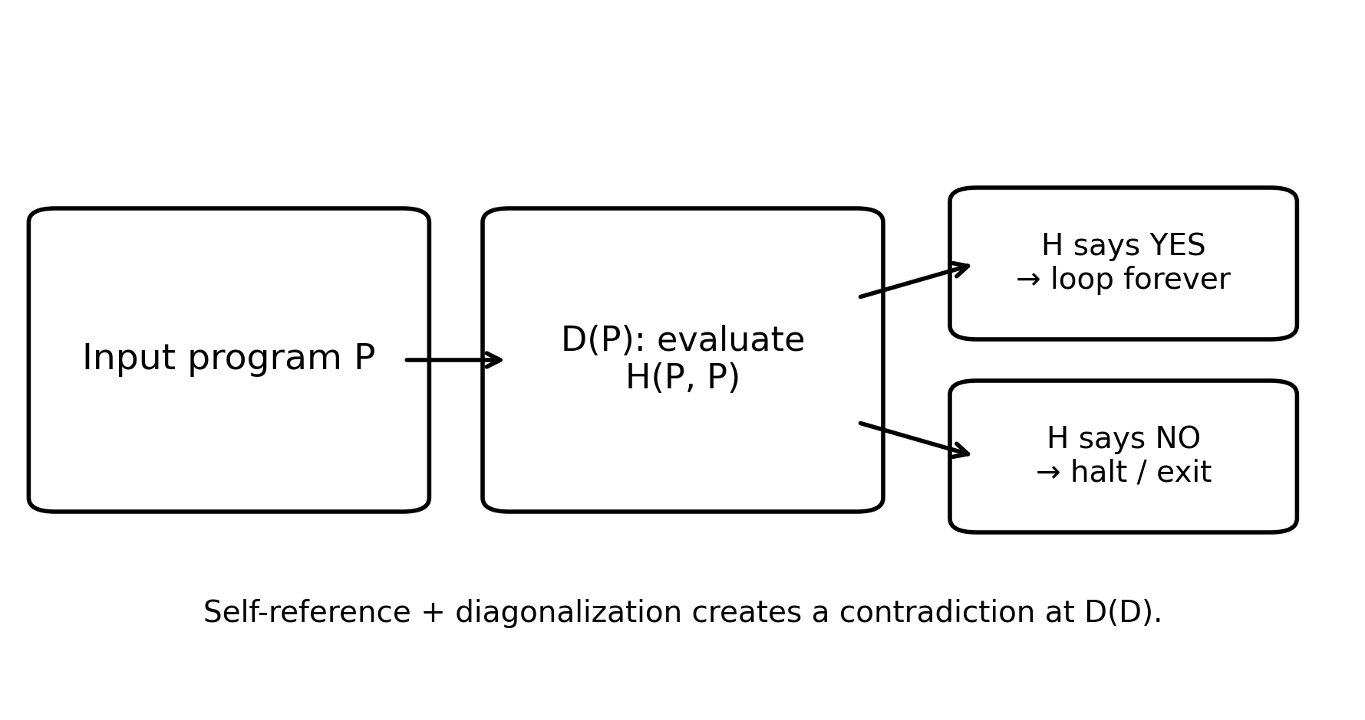

Halting Problem:
assume H(P, x)
H(P, x) = { YES, if P halts on x
NO, if P does not halt on x }
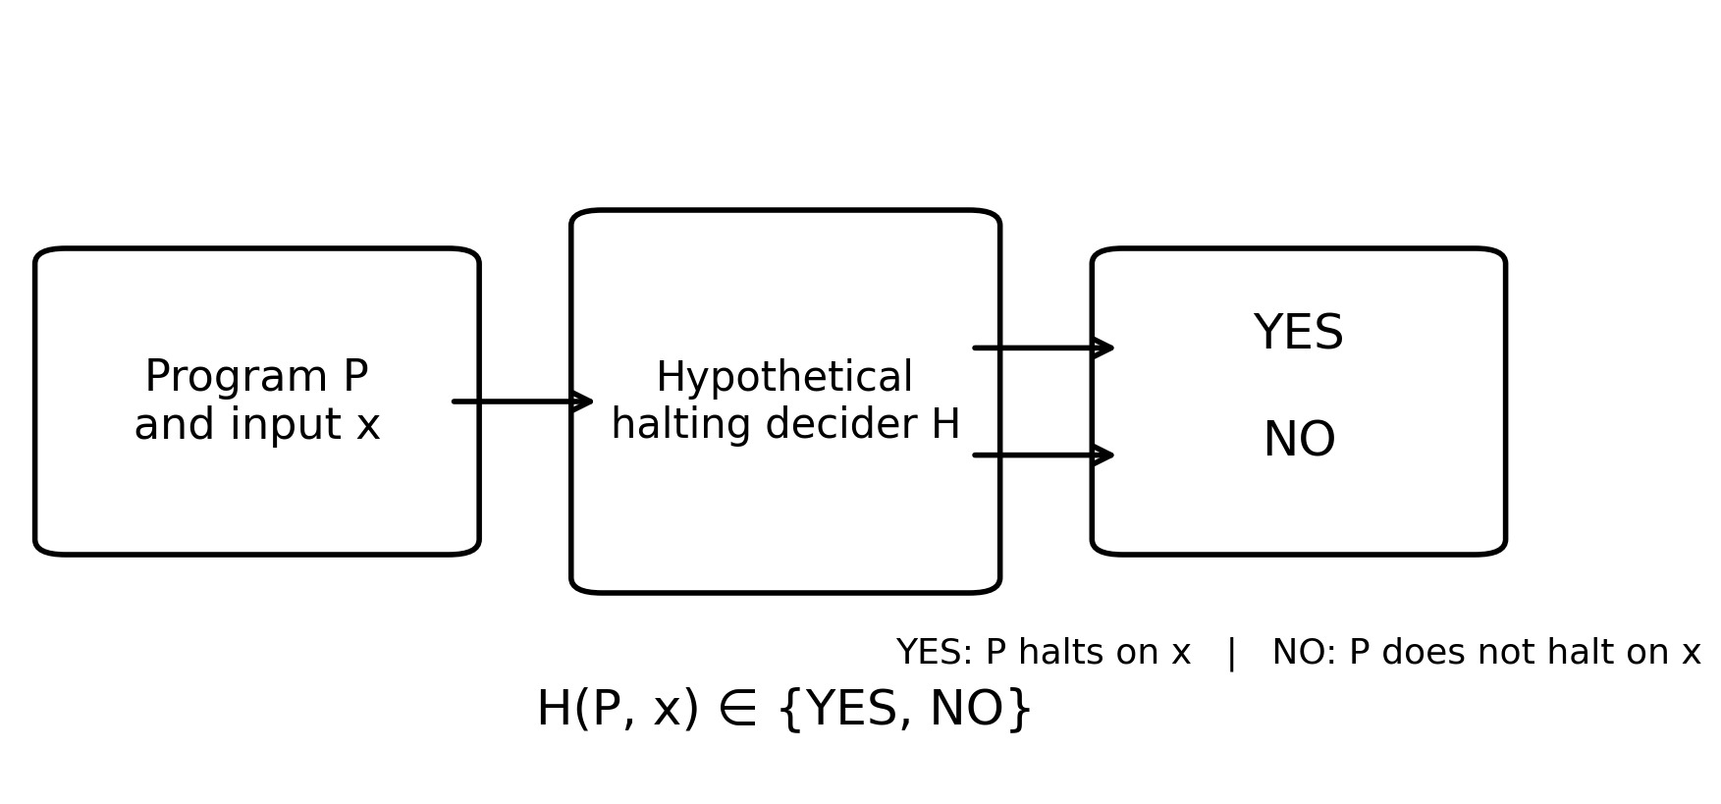
D(P, x):
if H(P, x) == YES:
loop forever
if H(P, x) == NO:
exit

D(D)

H(P, x) = YES / NO
if H(D) == yes → loop forever
if H(D) == no → exit

Halting Problem is undecidable.

